Assumptions:

* Employee Details Stored in Database ( In Enterprise Apps users will be authenticated using LDAP or OAuth etc.)
* Email Id and password will be used for Authentication.
* Password will be encoded and stored in DB.

Extra Feature:

* Even though the requirement talks about Giving feedback, I thought of having extra feature of seeking feedback from any employee in the Org.

User Login screen:

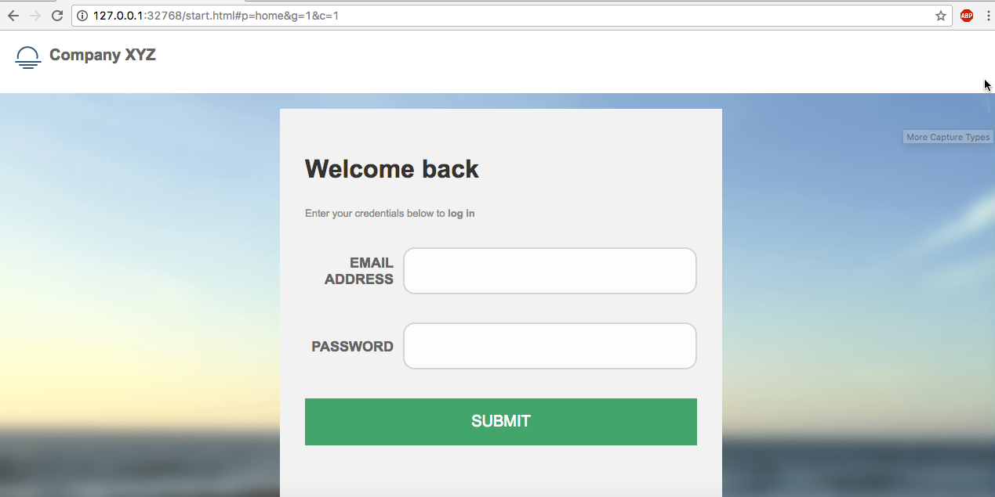

Once the User logs in-> lands in TO DO list page. This page lists the feedback requested by other employees

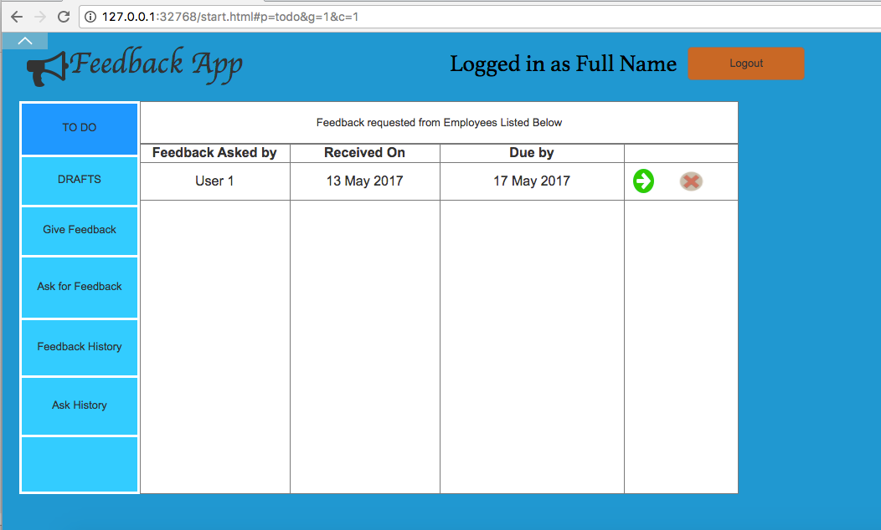

By Clicking **DRAFTS** link in left nav, user can navigate to feedbacks which are in progress or yet to send . On clicking the green arrow link user can navigate to the draft feedback page and work on it. By clicking X icon user can delete the draft item from DB.



By Clicking **Give Feedback** in the Left Nav, User can go to Feedback submit page in which an employee can be selected ( type ahead search based on employee name/ userid) and have option to select feedback as anonymous. User can give the employee overall rating and can rate for different categories as well . These categories can be maintained by admin. On submission of feedback, it appears in feedback history of submitter and receiver and email communication happens as well.

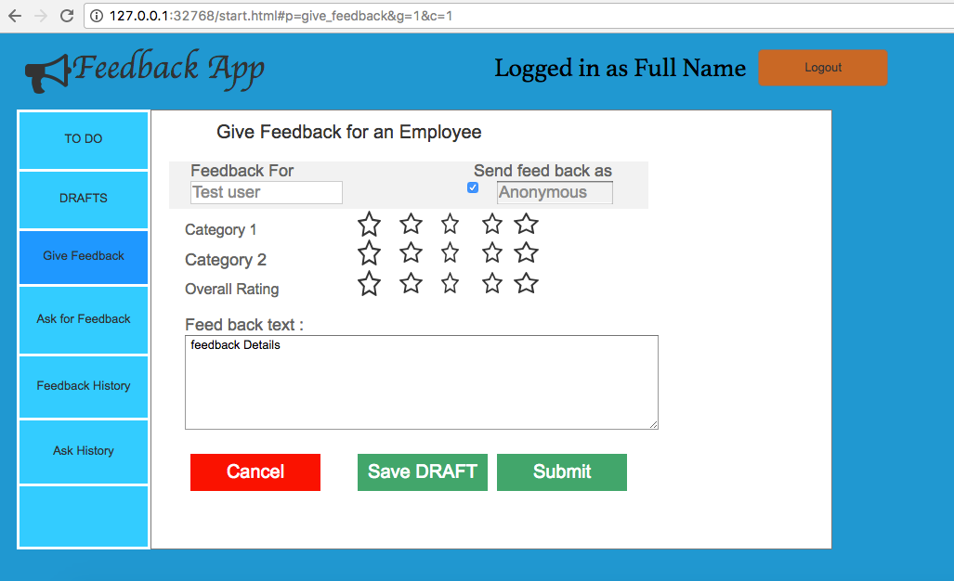

By Clicking **Ask for Feedback** any user can request feedback from any employee in the Organization. User can select employee name using type a head search and can enter due date and Email message body needs to be entered.

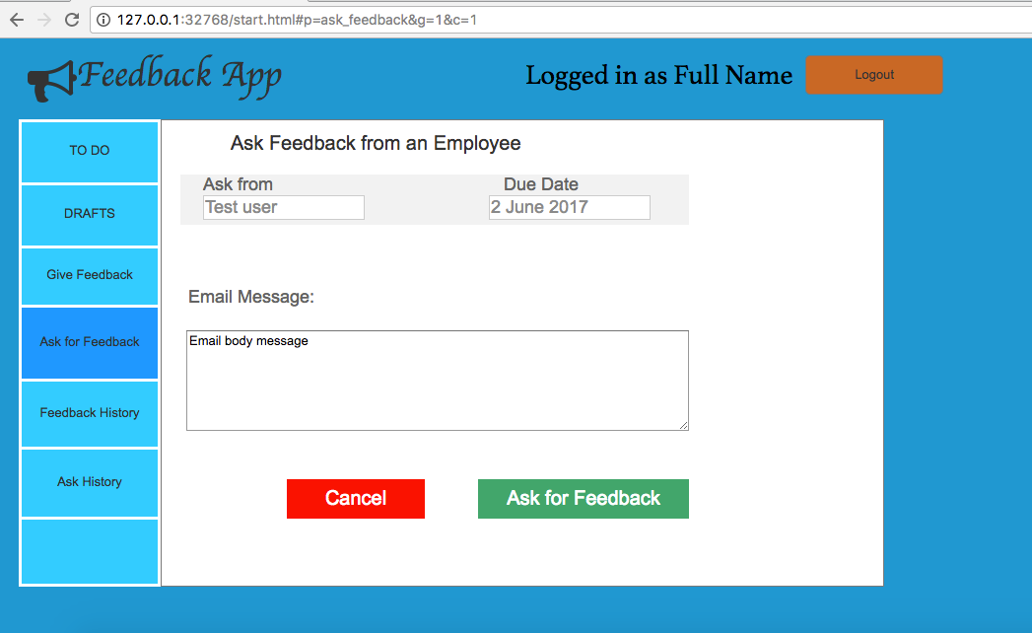

By clicking **Feedback History** link in left nav, User can see feed backs received from other employees and as well as feedback given to others. By clicking green arrow icon user can view complete details about the feedback ( feedback details page).

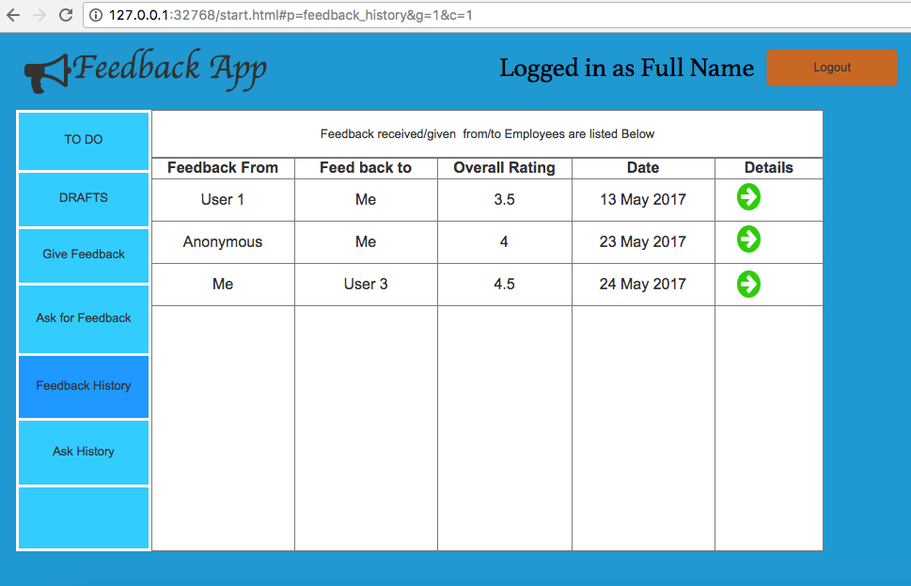

Feedback details page (read only content). By clicking arrow link user goes back to history page.

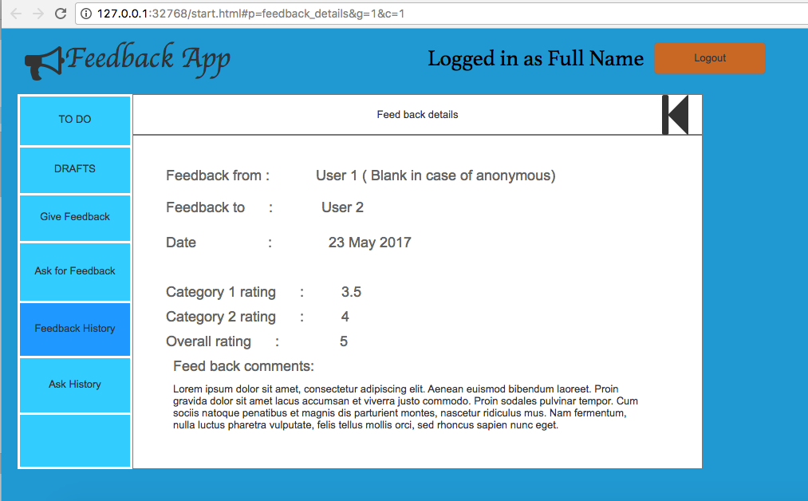

By clicking “**Ask History**” user can navigate to the list of feedbacks asked for. On clicking “**Received**” link User can navigate to feedback details page which is shown above.

